Pokhara University

Level: Bachelor | Semester – Spring | Year : 2008
Programme: BE |  | Full Marks: 100
Course: Engineering Mathematics I |  | Time : 3hrs.

Candidates are required to give their answers in their own words as far as practicable.
The figures in the margin indicate full marks.

Attempt all the questions.

 | - Show that the function f(x) = 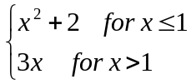 is continuous but not differentiable at x = 1.  OR  a) If y = tan⁻1x, show that  - (1 + x²)y₁ = 1  - (1 + x²)y_{n+1} + 2nxy_{n} + n(n-1)y_{n-1} = 0  - State and prove Cauchy Mean Value Theorem. Show that f(x) = x + 2 and g(x) = x² + 4 in [0, 2] verify Cauchy Mean Value Theorem. | 7  7  8
 | - Evaluate 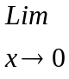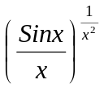  - Find the asymptotes of the curve  y³ – x²y + 2y² + 4y + x = 0  OR  If 40 square feet of sheet metal are to be used in the construction of an open tank with a square base. Find the dimension in order that its capacity is greatest. | 7  8  8
 | Integrate (Any Three)  - 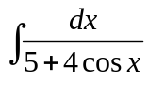  - 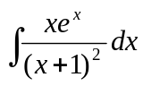  - 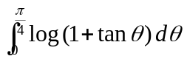  - 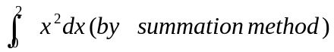 | 3×5
 | - Find the area bounded by the parabola x² = 4y and the curve y = 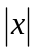  OR  Find the volume of the solid generated by the region in the first quadrant bounded by the parabola y = x² below by x – axis and on the right by the line x = 1, revolving about the line x = -1.  - Evaluate 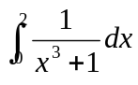by Trapezoidal rule and Simpson's rule taking n = 4. | 8  8  7
 | - Find by vector method the equation of the plane through the points (2, 4, 5), (1, 5, 7) and (-1, 6, 8).  - What does scaler triple product give? Explain Geometrically and prove that 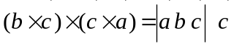 | 8  7
 | - Find the condition that the line 1x + my + n = 0 may touch the ellipse 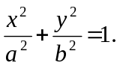  - Define conic section with different eccentricities. Derive the standard equation of hyperbola.  OR  A double ordinate of the parabola y² = 2ax is 4a. Prove that the line joining vertex to its ends is at right angle. | 8  7  7
 | Attempt all:  - Find the domain and range of the function f(x) = 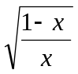  - Evaluate 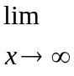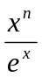  - Integrate 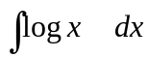  - if 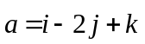 and 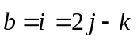 find unit vector of 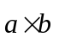  - If f(x) = tanx is Role's theorem applicable in [0, n]? Give reason. | 5×2

